**Project Title:** LinkedIn Scraper AI Bot

**Brief Description:** Developed an advanced LinkedIn Scraper Bot designed to enhance research capabilities by extracting and analyzing LinkedIn profile data. This bot leverages PhantomBuster for data extraction and OpenAI's ChatGPT for intelligent analysis, providing profound insights on individuals of interest. The solution automates the process of gathering and interpreting LinkedIn data, revolutionizing the way users understand and engage with professional profiles.

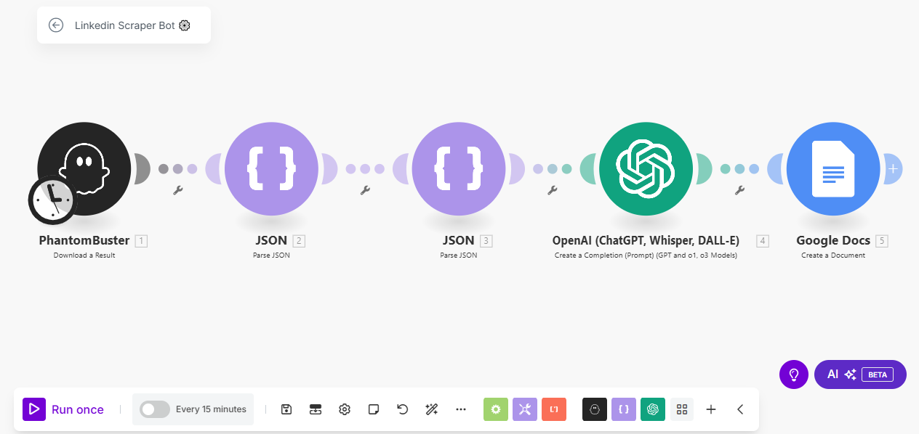

**Skills Used:** Data scraping, AI-driven analysis, automation, and workflow optimization using Make.com. The bot integrates PhantomBuster for efficient data extraction and OpenAI's ChatGPT for generating insightful analyses.

**Relevant Outcomes/Achievements:** Successfully implemented a zero-coding, plug-and-play solution that runs on autopilot, making it accessible for users without technical expertise. The bot's ability to extract and analyze data every 15 minutes ensures up-to-date insights. This project has empowered users to make informed decisions based on comprehensive LinkedIn profile analyses, enhancing their research and networking capabilities. The fully customizable nature of the bot allows users to tailor the analysis to specific needs, ensuring relevance and accuracy.

**Key Features:**

* Automated LinkedIn profile data extraction and analysis.
* Integration with PhantomBuster for efficient data scraping.
* AI-driven insights using OpenAI's ChatGPT.
* Fully customizable and adjustable to meet specific research requirements.
* Zero coding required, ensuring ease of use for non-technical users.